**Energy in a Cell and Cycling of Matter Lab**

Tanay Deshmukh

AP Environmental Science AB

Ms. Root

20 August 2020

**Introduction**

Photosynthesis is the process in which plants use the sun’s energy to convert carbon dioxide into oxygen. The goal of this lab is to “measure the rate of photosynthesis.” This is being done to demonstrate how and how fast photosynthesis occurs in a real setting. I hypothesize that if leaves are submerged in a bicarbonate solution and water, then the leaves in the bicarbonate solution will generate oxygen and float faster.

**Materials**

* + Baking soda
  + Two plastic syringes
  + Hole punch
  + Timer
  + Permanent Marker
  + Metric Ruler
  + Liquid dish soap
  + Baby spinach leaves
  + Clear plastic cups
  + Light source (100w bulb)
  + Plastic dropper

Below is an image of the materials I gathered for this experiment. The plastic dropper was out of the frame, and the timer was my phone.

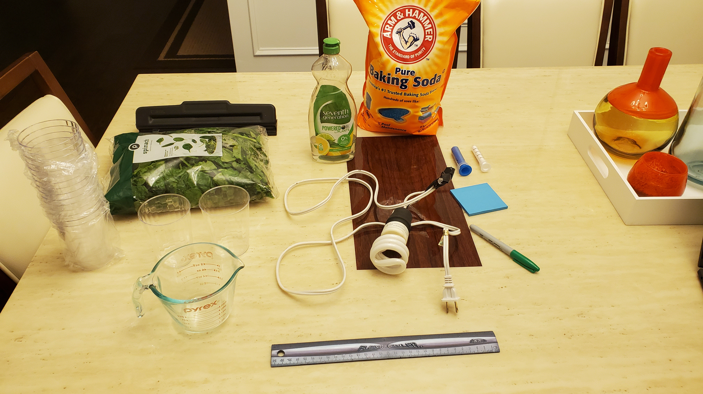

Procedures

* 1. Prepare 300mL of bicarbonate solution (see directions below). This solution will serve as a source of carbon dioxide for the leaf disks while they are in solution.
  2. Pour the bicarbonate solution into a clear plastic cup to a depth of about 3cm. Label this cup “CO2”.
  3. Pour water into a second clear cup to a depth of about 3cm. Label this cup “control.”
  4. Using a pipette, add one drop of dilute liquid soap (see directions below) to each cup. The soap will act as a wetting agent necessary to allow the solutions to be drawn into the leaves.
  5. Using a hole punch, punch 20 uniform disks. Try to avoid the veins of the leaves and choose sections that are smooth and not too thick.
  6. Label one syringe “CO2” and the other “control.” Remove the plunger from both syringes and place ten leaf disks into each syringe barrel. Carefully replace the plunger –do not crush the leaf disks. Push the plunger in until only a small volume of air remains in the barrel.
  7. Pull about 5cc of the CO2 plus soap solution into your “CO2” labeled syringe. Pull about 5cc of the control water plus soap solution into your “control” labeled syringe. Tap each syringe to suspend the leaf disks in the solution and push out the excess air,
  8. Now you will create a vacuum in the plunger to draw the oxygen out of the leaf tissue. This is the most challenging step! Create the vacuum by holding a finger over the narrow syringe opening while drawing back on the plunger. Hold this vacuum for about 10 seconds and swirl the leaf disks, so they are suspended in the solution. Check out the video in the sidebar for assistance on how this should be done.
  9. Open each syringe by removing the plunger and pour the disks into their corresponding cups - syringe “CO2” should empty into the “CO2” cup, and the “control” syringe should drain into the “control” cup.
  10. Place both cups under a light source and start the timer. At the end of each minute, swirl the solutions and record the number of floating disks. Continue collecting data until all of the disks in the “CO2” cup are floating.

The image below is what the experiment looks like when fully set up.

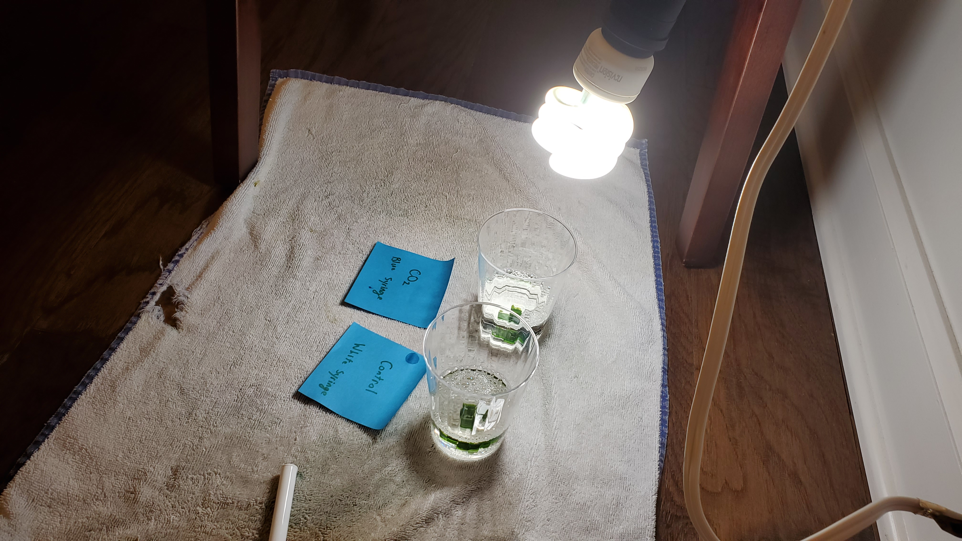

**Data**

Order for the Energy in a Cell Lab (*YouTube 2018)*:

|  |  |  |  |
| --- | --- | --- | --- |
| Energy | H2O, CO2, and Chlorophyll | Electron Transfer | ATP and NADPH |
| Calvin Cycle | Glucose and O2 |  |  |
| Glycolysis | Pyruvic Acid | Krebs Cycle | ATP, H2O, CO2 |

Data for the Cycling of Matter Lab:

* Result: After two attempts, a half hour each, the leaves never rose.

|  |  |  |
| --- | --- | --- |
| Time | Leaves floating in CO2 cup | Leaves floating in control cup |
| 0:00 | 0 | 0 |
| 30:00 | 0 | 0 |

* Note: Data is the same for all times in between.
* Above is the image of the leaves in the cup before the experiment. Left is labels CO2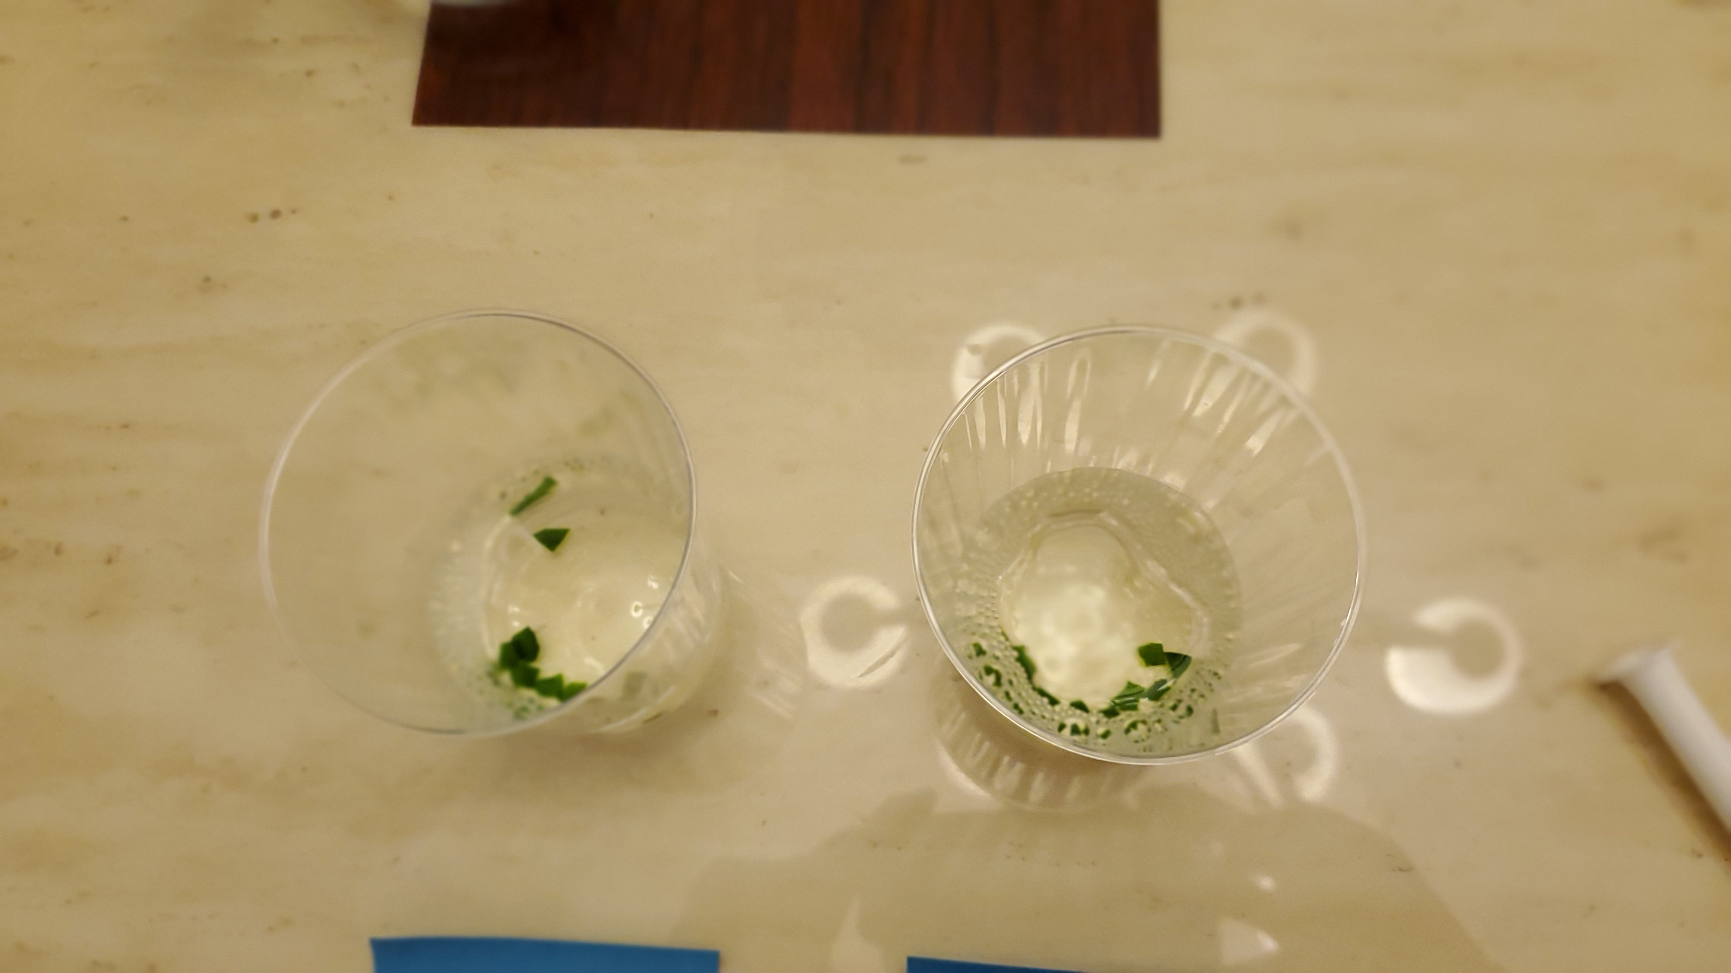 and right is label control.
* Below is the ima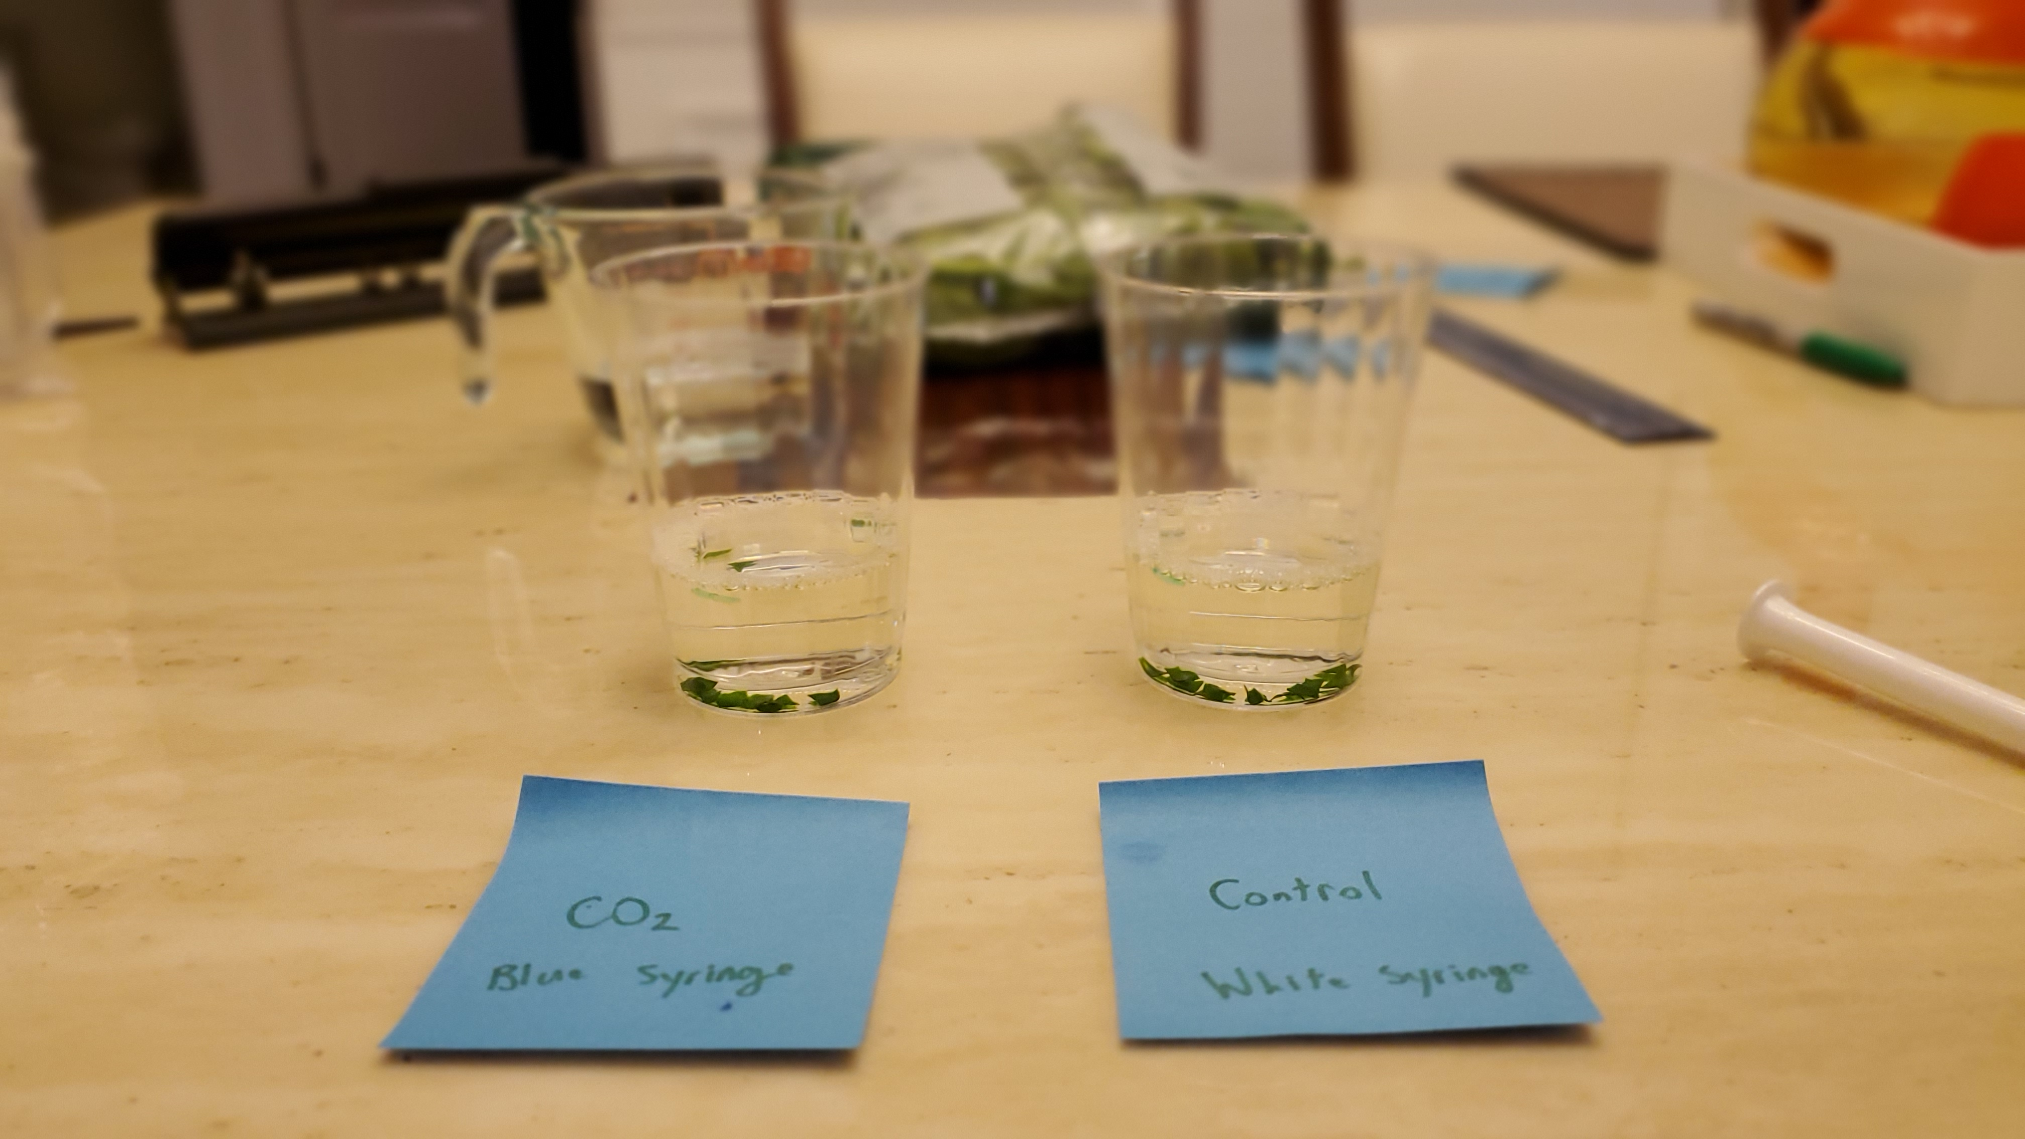ge of the leaves in cup after 30 mintues of stirring every minute. The leaves are still at the bottom.

**Analysis and Discussion**

Journal Questions:

1. What is the importance of light and dark reactions in photosynthesis?
   * Light reactions turn light into ATP and NADPH. Dark reactions turn ATP and NADPH into Energy (eSchooltoday).
2. What happens to food energy during photosynthesis? During cellular respiration?
   * Photosynthesis makes the food energy and stores it in molecules like ATP. Cellular respiration breaks down those molecules in which food energy is stored and provides it to the plant’s body.
3. Why is photosynthesis important to you?
   * The energy cultivated through photosynthesis is cultivated by plants and passed through the food chain until it eventually ends up in us. We would not have Energy if not for the plants that harvested it from the sun.
4. What are the processes in cellular respiration?
   * Cellular respiration has glycolysis, the Krebs or Citric acid cycle, and the Electron Transport Chain (C, R. 2018).
5. Why are photosynthesis and cellular respiration viewed as complementary processes?
   * Photosynthesis converts sunlight into energy, and cellular respiration takes that energy, breaks it down, and spreads it to the rest of the plant’s body.
6. Describe the similarities and differences between photosynthesis and cell respiration
   * Both serve to convert Energy into different forms. Photosynthesis is a light reaction, while cellular respiration can happen at any time of the day (it’s a dark reaction).

Graph for Cycles of Energy:

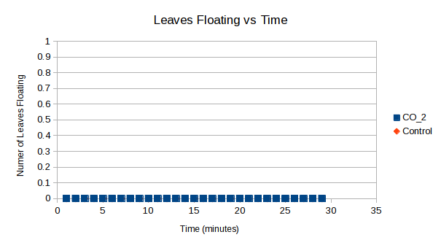

**Conclusions**

It seems as though my experiment failed even though I tried it twice and followed the instructional videos. Going off the data I collected, I found that the leaves did not float in either solution even after being left in the solutions for extended periods. This data is in direct contrast to my hypothesis that the leaves would float in the bicarbonate solution. The results I got were different from videos I saw on YouTube about the experiment, where their leaves ended up floating after just a few minutes. I suspect that the error stems from either an incorrect solution or the spinach leaves (which were wet when they came out of the bag). I should wash the spinach before the experiment, and maybe I can try to be more precise with my measurements for the solutions next time.

Please note, I was unable to access the Energy in a Cell lab, so I used the YouTube video cited below to understand what it contained. All answers to the questions are mine and mine only. I wanted to disclose this information just in case.

**References**

C, R. (2018, April 5). *Difference Between Cellular Respiration and Photosynthesis (with Comparison Chart)*. <https://biodifferences.com/difference-between-cellular-respiration-and-photosynthesis.html>.

eSchooltoday. *Light and dark reactions in photosynthesis*. What are dark and light reactions in photosynthesis? https://www.eschooltoday.com/photosynthesis/dark-and-light-reactions.html.

YouTube. (2018). *Energy in a Cell Lab Walkthrough*. https://www.youtube.com/watch?v=RoYbVOqnY9Q.